WELCOME TO MY 1st GLOBAL CITIZEN YEAR BLOG!
This blog is separated in three parts of MY STRUGGLING PAST, MY BRIGHT PRESENT, AND MY UNCERTAIN FUTURE story. Here we go....
(if you find any English mistakes, please let me know if your comments. I have no Excellent English, by the way).
MY STRUGGLING PAST,
I was born and raised up in Karachi, the very south of Pakistan. This is an unhappy and emotional PAST, because I had to go through some affected moments with hard time when I was a kid. The horrific moment when I lost my treasured father on the bike accident, but I was confident, faithful, and stayed strong.
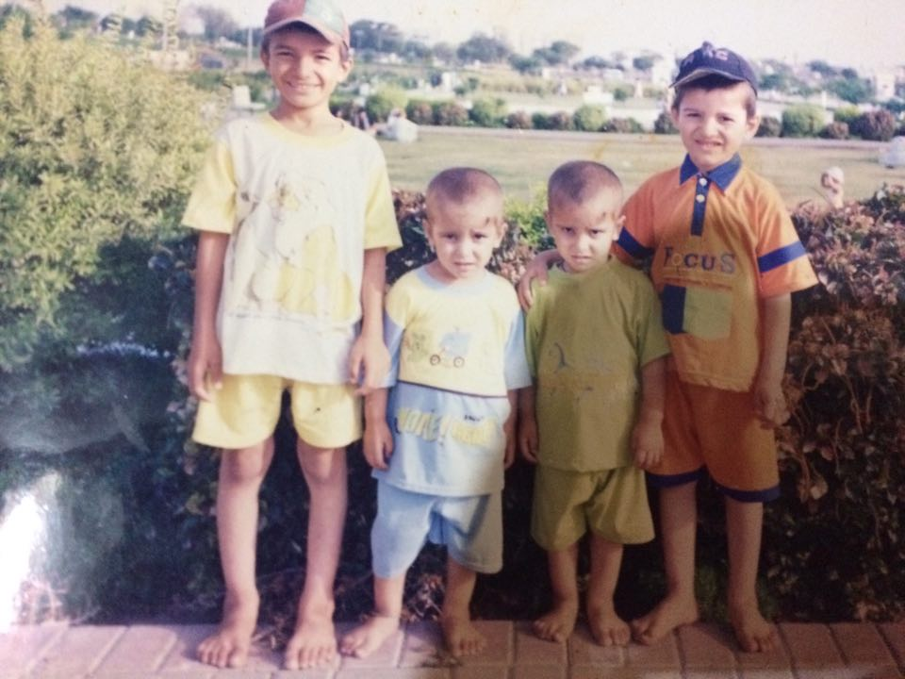
Life is never a fair game and it will never be. This unfairness goes when I lost my beloved and sweet Dad by an unexpected accident, which was an incredibly terrible. At this moment, I was only 7, and did have many siblings that needed support of my father. My mum and my sisters, which were older in my siblings, were the only people that I gained hope from and lots of support when I was going through hard times.
I was in primary school, and was performing as a good student, but, my dreams started to be crushed, because, I lost my support, my father. At this moment, my life started to deviate into a new direction, it was a scholarship grant until my matric grade. I worked hard and tried to gain support from my school. And, at the end, I got an opportunity to do some English Language learning program. I applied, and I got into this program which was for two complete years. It was an opportunity that unlocked all my doors of skills. Through this program, I was fortunate to do a multicultural program in Turkey for two weeks. I was so lucky that I was successfully graduated from my school and received a complete certificate for my English Language Program. At this moment, one of my biggest struggles came into an evil, it was, what I AM GONNA DO NEXT. Then miraculously, one of my best friends told me some stuffs about UWC and he recommended to apply to UWC program, about which I was zero.
Image 01: My oldest brother (left), me, my twin, and my second oldest brother.
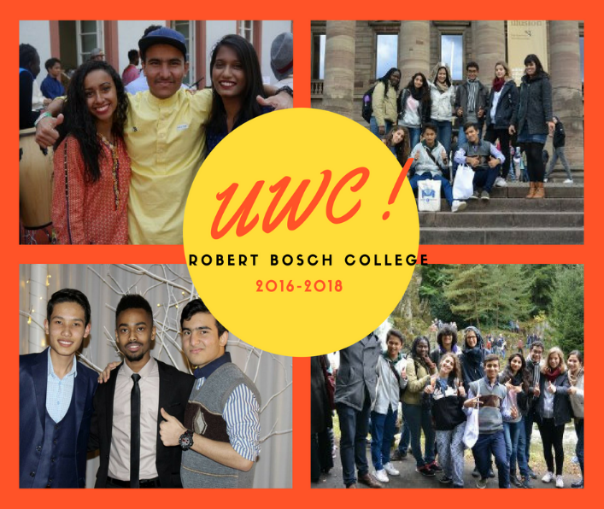
I read about UWC and it did seem an interesting program, but their requirements were shocking. However, I had no choice other than to apply to UWC scholarship. I said to myself, it is better trying than giving up without any attempt. I offered my best attempt and did my best in all areas of application process. At this point, my life began to shine as stars in the night. I received good news of my acceptance to UWC scholarship, which was full and my dream-come-true moment. I was chosen for UWC Robert Bosch College in GERMANY for 2 years. When good things like UWC scholarship happen, I say to myself that I AM DREAMING, but when I face hard times, I do realize that life gives opportunities to everyone and it’s up to them how to use them. And, I used this life-changing opportunity in the shape of UWC scholarship.
I spent my amazing 2 years in UWC Robert Bosch College in Germany, and recently, I was graduated, and I chose to embark a new journey called Global Citizen Year, which is detailed in MY BRIGHT PRESENT story.

MY BRIGHT PRESENT;
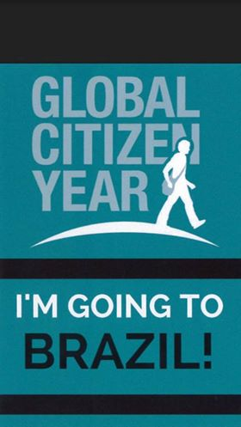
Indeed, my past not been a good one as I dreamt. But, I am happy that my PRESENT is so living, amazing and bright time that I could imagine. After I graduated UWC RBC Germany, I started to think of my future that WHAT AM I UP TO NOW. I did research a lot what, when and why I should do college after my high school. Afterwards, I came to conclusion that I need a BREAK, which was in shape of a bridge year. I stopped thinking of all those stressing years of College life, but I started thinking of having a multicultural time and opening myself to new things, like traveling to new places, learning new traditions, religion, culture and language. I went to my counselor, and he recommended me to apply to GLOBAL CITIZEN YEAR if I want to experience things that I have mentioned above. I applied and went through all procedures that everybody does to get into GCY program. I was happy to be selected as a GCY Fellow to be going to BRAZIL. I loved it more when I heard that I am heading to BRAZIL. Things like big mountains, fantastic beaches and amazing people, but tough language came into my mind.
In the latest May, I finished my UWC RBC and went back to Pakistan. It was all hard weather and hard time in family. I had to complete so many things like visa, travel, and immunizations process for my GCY application. About immunizations, they almost killed me, but I survived, because I knew I had to travel Brazil before I die. About visa, I travelled so many places and explored new things like Brazil Embassy and consulates. I was doing good in all things like updating my documents and accomplishing their requirements. I finished everything and received my visa so late, I mean, it took me 35 days. I already booked my tickets for flights. That’s how, I accomplished to get rid of all the requirements before my departure to San Francisco for GLOBAL CITIZEN YEAR.
Now its August, I was done with my packing and language learning, Rosetta Stone (it’s a language learning platform) was a bit helpful though. I was embarking a completely new journey to US, BRAZIL and GLOBAL CITIZEN YEAR (GCY). One thing that I don’t personally like is long flights. I was travelling with my colleague from a different city. We were super ready and excited to embark the GCY Journey. I swear, we were freaking tired of 17 hours flights from Dubai to San Francisco, but we had 2 hours from Pakistan to Dubai, which was okay. It took us long, but we made it until the end, in San Francisco. Here, I liked the weather and people were also nice. Last part of this story, as we were dropped from our journey, there were GCY people who took us to Stanford University for GCY Journey, and we were immersed into GLOBAL LAUNCH, which will be shared in my other blog, stay tuned.

MY UNCERTAIN FUTURE:
Things had been hard in Past but are good in Present. Therefore, it is to say that my FUTURE IS UNCERTAIN. However, at Present, I am doing a bridge year, but after this year, I am planning to start a new journey which is not a bridge year, but survival-of-the-fittest year, it’s a College life. I do like to plan, but now, I got to enjoy my Bridge year, then I will start worrying about my future. So, I will keep posted my future for my UNCERTAIN FUTURE.

